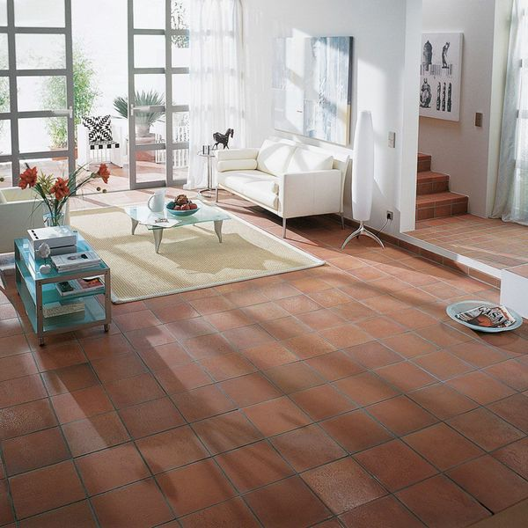**Aragon Flat Red Quarry Tiles:**

## **Product Description**

Create a rich, natural look in your home with these fantastic Aragon Flat Red Quarry Tiles. Their burnt, red colour will add depth and character to any kitchen, bathroom, hallway or lounge.

Due to the natural nature of these quarry tiles, tile thickness can vary 1-2mm.

**What's special about these tiles?**

> Natural clay

> Subtle matt finish

> Suitable for internal and external use

> Rustic, square shape

**Sealing, cleaning and maintenance**

For a matt finish:

**Sealer**: We recommend sealing these tiles with [LTP Mattstone Tile Sealer](https://www.wallsandfloors.co.uk/ltp-cleaning-protecting-ltp-mattstone-tile-sealer-11256) or LTP Mattstone H20 Tile Sealer. Both sealers fill the open pores on the surface, leaving the tile in its natural appearance.

**Cleaning and aftercare:** To keep these tiles clean, we recommend [LTP Waxwash](https://www.wallsandfloors.co.uk/ltp-cleaning-protecting-ltp-waxwash-tile-maintenance). It contains a trace of linseed oil which will help to repair and maintain the sealer without altering the finish.

For a satin to gloss finish:

**Sealer:** We recommend sealing these tiles with [LTP Glaze Protector](https://www.wallsandfloors.co.uk/ltp-cleaning-protecting-ltp-tile-glaze-protector). The glossiness slightly increases with every application, depending on the desired appearance and can be applied up to a maximum of 6 coats. It's for dry areas and internal use only.

**Cleaning and aftercare**: Regularly use [LTP Floorshine](https://www.wallsandfloors.co.uk/ltp-cleaning-protecting-ltp-floorshine-tile-maintenance) to increase the sheen and repair old worn sealer.

## **Product INFO**

* Product ID 11509
* Tiles Per SQM 44.444444444444
* Sale by Per SQM
* Size 150x150x12mm
* Weight 0.61 KG
* Material Type Clay
* Finish Matt
* Colour Terracotta
* Suitability Floors
* Grade 5
* Rectified Edge No
* Underfloor Heating Yes
* Thickness (mm) 12
* Thickness (mm) 10